

WEATHER CONDITION PREDICTION USING MACHINE LEARNING

Submitted by

A.Pranathi
NC.AI.U4AID25005
for

23AID205/INTRODUCTION TO AI & ML

of

DEPARTMENT OF ARTIFICIAL INTELLIGENCE AND DATA SCIENCE

on

28-03-2026

Table of Contents
S.No | Description | Page No
1. | Abstract | 3
2. | Introduction | 3-4
3. | Problem Statement | 4
4. | Objectives | 5
5. | Literature Review | 5-6
6. | Methodology | 6-7
7. | Dataset Description | 7-8
8. | Implementation | 8-16
9. | Results & Performance Analysis | 16
10. | Conclusion | 17-18
11. | Future Work | 18-19
1.Abstract:
Weather conditions have a major influence on daily life, agriculture, transportation, travel, and several other activities. Changes in temperature, humidity, wind speed, atmospheric pressure, and other environmental factors can result in different weather conditions. Therefore, predicting weather conditions from available weather data can be useful for understanding weather patterns and supporting better planning and decision-making.
This mini-project presents a Weather Condition Prediction System Using Machine Learning. The main objective of the project is to develop a machine learning model that can predict weather conditions based on historical weather parameters. The system uses relevant features such as temperature, humidity, wind speed, atmospheric pressure, and other available environmental measurements. The collected dataset is first examined and preprocessed to improve its quality and make it suitable for machine learning.
After preprocessing, the relevant features are provided to a classification algorithm for model training. The trained model learns patterns from historical weather observations and uses these patterns to predict the corresponding weather condition for new input data. The performance of the model is evaluated using suitable measures such as accuracy, classification results, and a confusion matrix.
The project demonstrates the practical application of artificial intelligence and machine learning in weather-related prediction. It provides a simple and understandable approach to analysing weather data and identifying patterns. The developed system can also serve as a foundation for future improvements using larger datasets, additional weather parameters, and more advanced machine learning techniques.
2.Introduction:
Weather is an important part of the environment and has a direct effect on human activities. Changes in weather conditions influence agriculture, transportation, tourism, outdoor activities, and daily planning. Weather conditions can change because of variations in temperature, humidity, wind speed, atmospheric pressure, cloud cover, and other environmental factors. Understanding the relationship between these parameters can help in identifying weather patterns and predicting possible weather conditions.
Traditional weather prediction methods generally depend on observations, measurements, and complex forecasting techniques. With the development of Artificial Intelligence and Machine Learning, historical weather data can be analysed to identify patterns and relationships between different weather parameters. Machine learning algorithms can learn from previously recorded observations and use the learned patterns to classify or predict the weather condition for new observations.
This project focuses on developing a Weather Condition Prediction System Using Machine Learning. The system uses historical weather data containing different environmental parameters as input. The data is first analysed and preprocessed to handle missing or unsuitable values and to prepare the features for model training. Relevant weather parameters are then used to train a machine learning classification model.
The trained model learns the relationship between the input weather parameters and the corresponding weather condition. When new weather data is provided, the model uses the learned patterns to predict the expected weather condition. The performance of the model can be evaluated using measures such as accuracy, classification report, and confusion matrix.
The main purpose of this project is to demonstrate a practical application of Artificial Intelligence and Machine Learning in weather analysis. It provides an understandable approach to working with real-world environmental data and shows how machine learning can be used to support weather condition prediction.
3.Problem Statement:
Weather conditions change frequently due to variations in temperature, humidity, wind speed, atmospheric pressure, and other environmental factors.
Analysing these parameters manually makes it difficult to identify patterns and determine the expected weather condition.
Large amounts of historical weather data also make traditional analysis time-consuming.
Therefore, there is a need for a reliable approach to analyse weather parameters and identify the corresponding weather condition.
The project focuses on addressing this problem by using available weather data to make accurate weather condition predictions.

4.Objectives:
1.To collect and analyse historical weather data containing relevant environmental parameters.
2.To preprocess the weather dataset by handling missing values and preparing the data for machine learning.
3.To identify the important weather parameters that influence weather conditions.
4.To develop a machine learning classification model for predicting weather conditions.
5.To evaluate the performance of the developed model using suitable evaluation metrics.
6.To demonstrate the practical application of machine learning in weather condition prediction.
5.Literature Review:
1. Safia, Abbas and Aslani (2023) studied Classification of Weather Conditions Based on Supervised Learning for Swedish Cities. The study used weather parameters such as temperature, pressure, humidity, wind speed and wind direction to classify different weather conditions. The researchers compared supervised learning methods including Artificial Neural Networks (ANN), Support Vector Machines (SVM), Random Forest (RF), and K-Nearest Neighbors (KNN). The study demonstrated the usefulness of supervised machine learning for weather-condition classification.
2. Shrivastava et al. (2023) presented a study on Deep Learning Model for Temperature Prediction: A Case Study in New Delhi. The researchers investigated temperature prediction using machine learning and deep neural network models. Different combinations of weather parameters, including temperature, pressure, humidity and dew point, were considered as input features. The study showed how multiple meteorological variables can be used together for improved weather-related prediction.
3. Bochenek and Ustrnul (2022) reviewed Machine Learning in Weather Prediction and Climate Analyses—Applications and Perspectives. The study discussed the growing use of machine learning techniques in weather forecasting and climate analysis. It highlighted applications of ML in different weather-related prediction tasks and showed the potential of data-driven approaches for analysing complex atmospheric information.
4. Zhang et al. (2025) presented Machine Learning Methods for Weather Forecasting: A Survey. The researchers reviewed different machine learning methods used for weather forecasting and discussed their ability to analyse large and complex datasets. The study also identified challenges such as model interpretability and prediction of rare weather events.
5. V. Rithesh Choudary et al. (2025) conducted a Comparative Analysis of Machine Learning Approaches for Heatwave Event Prediction in India. The study compared several machine learning and deep learning techniques for heatwave classification using weather-station data from Chennai, Tamil Nadu. The research highlighted the importance of selecting suitable models and handling challenges such as class imbalance in weather-related prediction tasks.
6. A 2025 study on Weather Classification using Pre-trained CNNs investigated deep learning approaches for automatic weather classification. Different pre-trained convolutional neural networks, including ResNet50V2, EfficientNetB5 and EfficientNetV2S, were evaluated on multiple weather classes. EfficientNetV2S achieved an accuracy of 92.35%, demonstrating the potential of deep learning for automated weather classification.
6.Methodology:
The proposed system follows a series of steps to predict weather conditions using machine learning. The methodology consists of data collection, data preprocessing, feature selection, model training, prediction, and performance evaluation.
1. Data Collection:
A historical weather dataset containing different meteorological parameters is collected. The dataset includes relevant features such as temperature, humidity, wind speed, atmospheric pressure, and other available weather measurements along with the corresponding weather condition.
2. Data Preprocessing:
The collected dataset is examined for missing values, duplicate records, and unsuitable data. Missing or inconsistent values are handled appropriately, and categorical values are converted into a suitable numerical format when required. This step ensures that the dataset is suitable for machine learning.
3. Feature Selection:
Relevant weather parameters are selected as input features for the model. The selected features are used to identify the relationship between weather conditions and the environmental parameters.
4. Model Training:
The processed dataset is divided into training and testing data. A suitable machine learning classification algorithm is trained using the training data. The model learns patterns from the historical weather observations and their corresponding weather conditions.
5. Weather Condition Prediction:
After training, the model is provided with unseen test data. Based on the learned patterns, it predicts the weather condition associated with the given weather parameters.
6. Performance Evaluation:
The predictions are compared with the actual weather conditions in the test dataset. Model performance is evaluated using accuracy, classification report, and confusion matrix. These measures help determine how effectively the model classifies different weather conditions.
7. Result Analysis:
The obtained results are analysed to understand the performance of the developed model. Graphs and evaluation results are used to present the model's performance clearly.
7.Dataset Description:
The dataset used for this project contains historical weather observations collected for analysing and predicting different weather conditions. Each record represents a particular weather observation and contains several meteorological parameters that can influence the observed weather condition.
The dataset includes relevant features such as temperature, humidity, wind speed, atmospheric pressure, cloud-related measurements, and other available weather parameters. These features are used as input variables for the machine learning model. The dataset also contains a weather condition attribute, which is considered the target variable that the model learns to predict.
Before using the dataset for model training, the data is examined for missing values, duplicate records, inconsistent values, and unsuitable entries. The required preprocessing and transformation steps are then performed to make the data suitable for machine learning.
The weather parameters are treated as independent features, while the weather condition is treated as the dependent or target variable. The prepared dataset is divided into training and testing sets. The training portion is used to build the machine learning model, while the testing portion is used to evaluate its prediction performance on unseen weather observations.
The dataset provides a practical basis for studying the relationship between meteorological parameters and weather conditions and for demonstrating the application of machine learning to a real-world prediction problem.
8.Implementation:
Code:

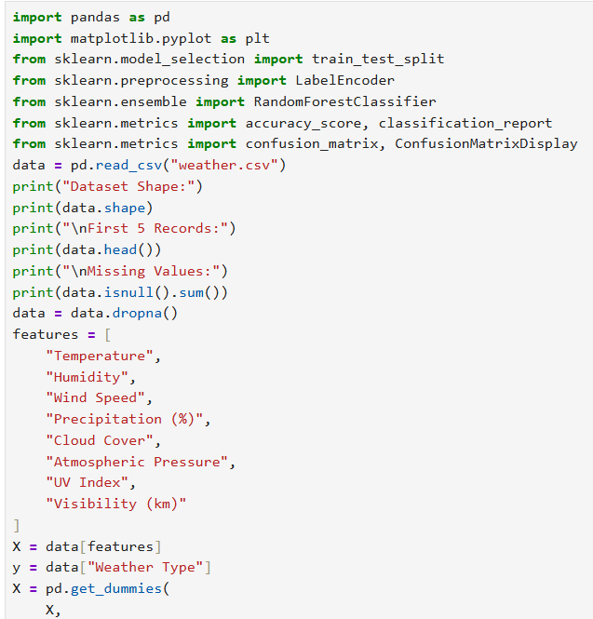
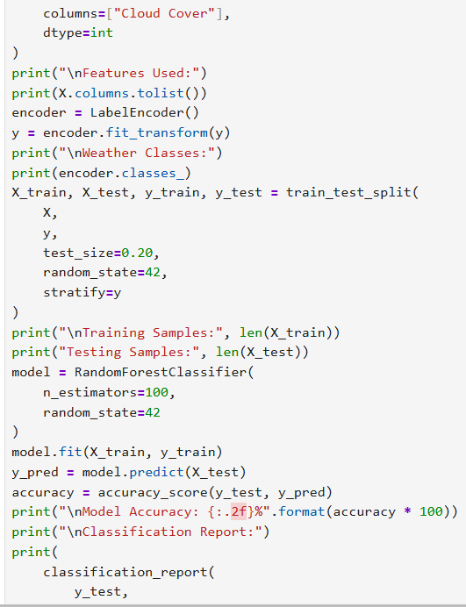
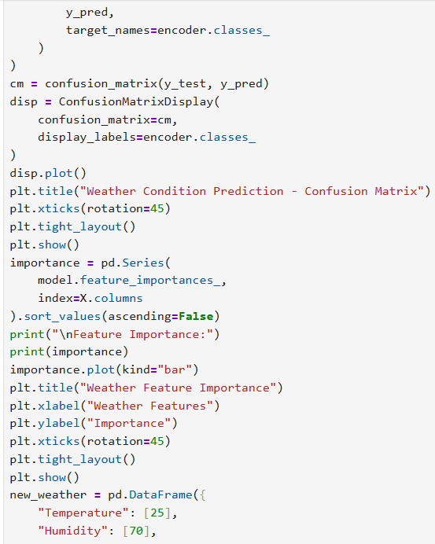
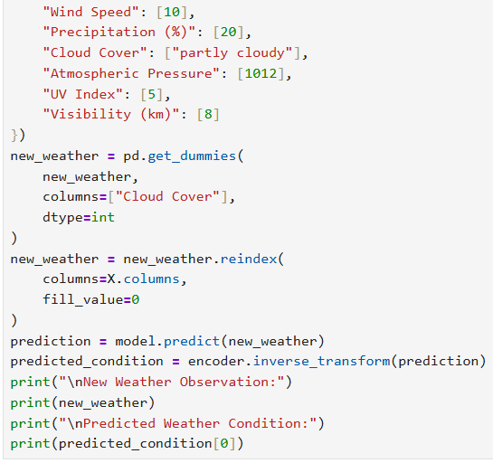

Output:
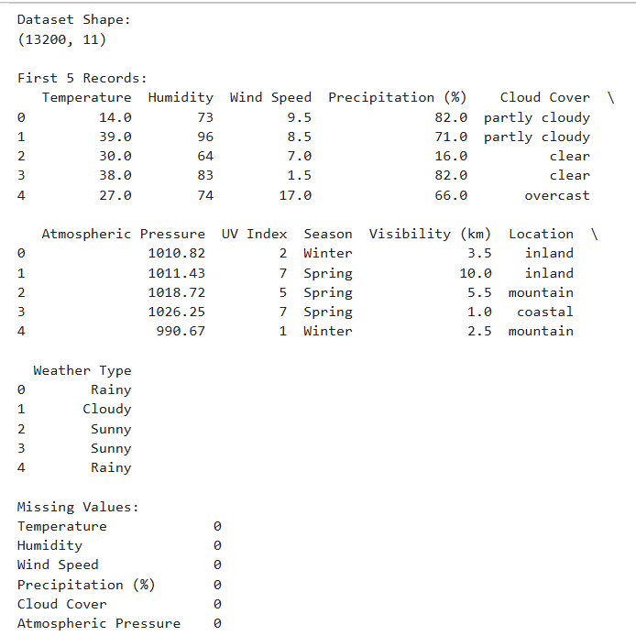
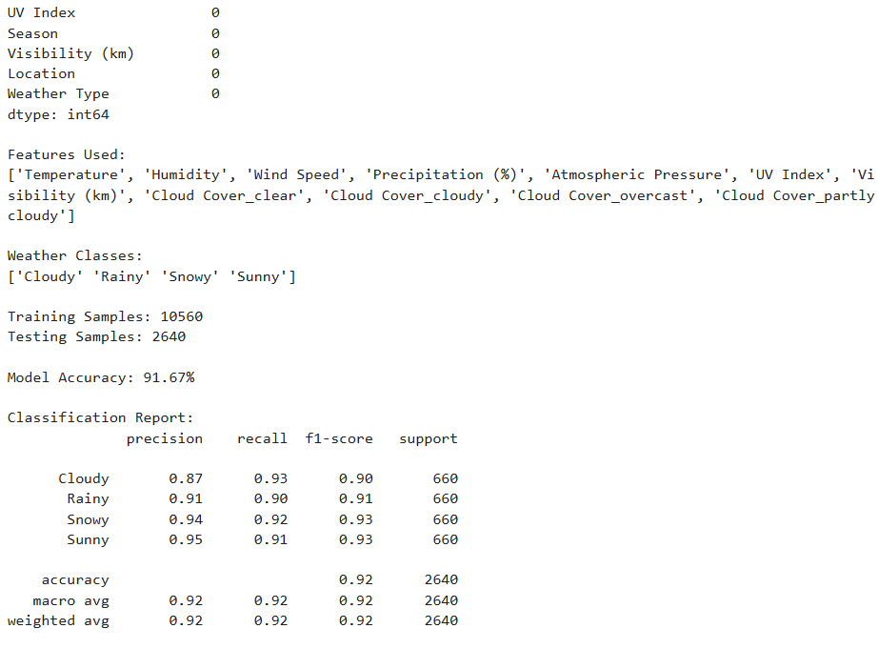
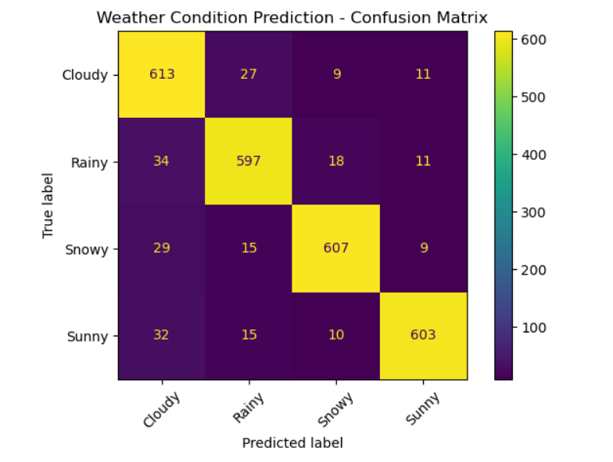
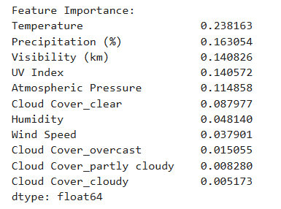
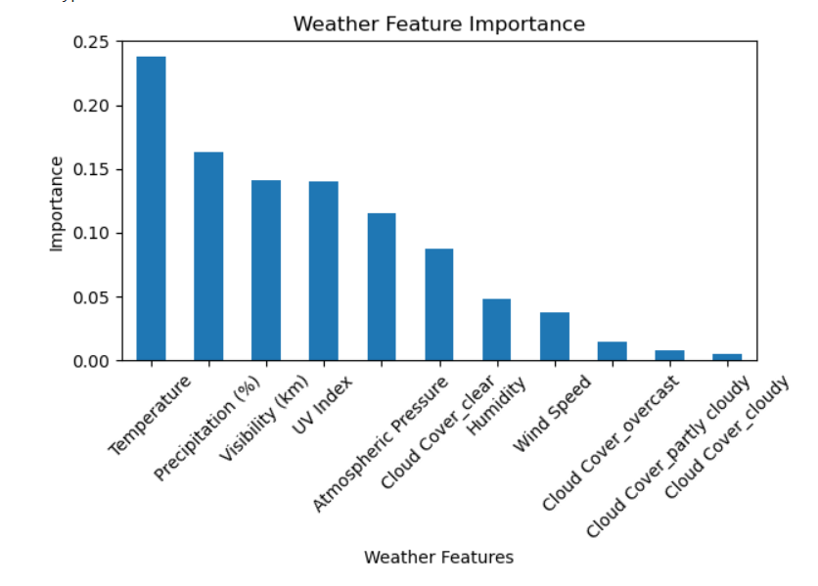
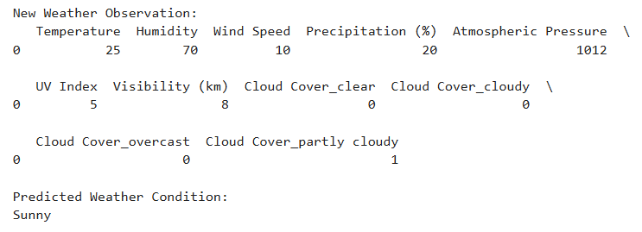
9.Results & Performance Analysis:
The Weather Condition Prediction system was successfully developed using machine learning techniques. The dataset contained 13,200 weather records with parameters such as temperature, humidity, wind speed, precipitation, cloud cover, atmospheric pressure, UV index, and visibility. The dataset was checked for missing values, and no missing values were found. The weather conditions were classified into four categories: Cloudy, Rainy, Snowy, and Sunny.
The dataset was divided into 80% training data and 20% testing data, with 10,560 records used for training and 2,640 records used for testing. A Random Forest Classifier was used to learn the relationship between weather parameters and weather conditions. Categorical values such as cloud cover were converted into numerical form before training.
The model performance was analysed using accuracy, classification report, confusion matrix, and feature importance. The confusion matrix was used to observe the correct and incorrect predictions for each weather category, while the feature-importance graph helped identify the weather parameters that contributed to the prediction. The trained model was also tested with a new weather observation and successfully generated a predicted weather condition.
Overall, the implementation demonstrates that machine learning can be effectively applied to analyse weather parameters and classify different weather conditions. The results show the practical usefulness of the Random Forest approach for automated weather condition prediction.

10.References:
1.Bochenek, B., & Ustrnul, Z. (2022). Machine Learning in Weather Prediction and Climate Analyses—Applications and Perspectives. Atmosphere, 13(2), 180. https://doi.org/10.3390/atmos13020180.
2.Safia, M., Abbas, R., & Aslani, M. (2023). Classification of Weather Conditions Based on Supervised Learning for Swedish Cities. Atmosphere, 14(7), 1174. https://doi.org/10.3390/atmos14071174.
3.Shrivastava, V. K., Shrivastava, A., Sharma, N., Mohanty, S. N., & Pattanaik, C. R. (2023). Deep Learning Model for Temperature Prediction: A Case Study in New Delhi. Journal of Forecasting, 42(6), 1445–1460. https://doi.org/10.1002/for.2966.
4.Zhang, H., Liu, Y., Zhang, C., & Li, N. (2025). Machine Learning Methods for Weather Forecasting: A Survey. Atmosphere, 16(1), 82. https://doi.org/10.3390/atmos16010082.
5.Choudary, V. R., Johnvictor, A. C., & Sankar, P. N. (2025). Comparative Analysis of Machine Learning Approaches for Heatwave Event Prediction in India. Scientific Reports, 15, 22431. https://doi.org/10.1038/s41598-025-04634-9.
6.Weather Classification Using Pre-trained Convolutional Neural Networks. (2025). Study comparing pre-trained CNN architectures including ResNet50V2, EfficientNetB5, and EfficientNetV2S for weather classification.
11.Conclusion:
The Weather Condition Prediction Using Machine Learning project successfully demonstrates the use of machine learning for classifying weather conditions based on different environmental parameters. The dataset was preprocessed and analysed to identify useful weather features such as temperature, humidity, wind speed, precipitation, cloud cover, atmospheric pressure, UV index, and visibility.
A Random Forest Classifier was used to train the prediction model and classify weather conditions into Cloudy, Rainy, Snowy, and Sunny categories. The model was evaluated using accuracy, classification report, confusion matrix, and feature-importance analysis. The system can also predict the weather condition for a new set of weather observations.
Overall, the project demonstrates how Artificial Intelligence and Machine Learning can be applied to weather data analysis and prediction. It provides a simple and practical approach for understanding weather patterns and automatically identifying weather conditions from available environmental data.
12.Future Work:
The Weather Condition Prediction Using Machine Learning project can be further enhanced in several ways to improve its accuracy, usefulness, and practical application. The current system uses a fixed historical dataset and predicts weather conditions based on selected weather parameters. In the future, the system can be extended to handle larger and more diverse datasets collected from different geographical locations and different time periods.
The prediction system can be improved by including additional weather parameters such as rainfall intensity, wind direction, dew point, solar radiation, air quality, and visibility changes. These additional features may provide more information about weather patterns and help the model identify different weather conditions more effectively.
Different machine learning algorithms such as Decision Tree, Support Vector Machine, K-Nearest Neighbours, Gradient Boosting, and other ensemble methods can be implemented and compared with the Random Forest model used in the current project. Hyperparameter tuning and suitable feature-selection techniques can also be applied to improve the performance of the prediction model.
The project can also be extended from simple weather classification to predicting future weather values, such as temperature, rainfall, and humidity. Time-series and deep learning techniques can be explored for analysing weather data collected over longer periods and identifying changes in weather patterns.
Another important improvement would be the development of a real-time weather prediction system. The system can be connected to live weather data sources or sensors so that current environmental conditions can be automatically collected and processed. Based on the received data, the trained model can provide an immediate prediction of the expected weather condition.
A user-friendly web or mobile application can also be developed in the future. Users could enter weather parameters manually or allow the application to obtain them automatically. The predicted weather condition could then be displayed using simple text, charts, and visual indicators.
Finally, the system can be continuously improved by retraining the model with newly collected weather data. This can help the model adapt to changing weather patterns and improve its usefulness for practical applications such as agriculture, transportation, travel planning, and environmental monitoring.
13.GitHub Link:

